To: ABC European Bank
From: Sheyma Abdikebir
Re: Customer Churn Predictive & Prescriptive Analytics Final Report

Introduction

Customer retention has an utmost importance when it comes to keeping banks profitable and allowing them to have long term growth. In the banking sector, banks face heightened competition, making customer retention a difficult task. To help banks reduce churn, it is crucial to use machine learning models to predict customers at risk of churning (mihup, 2024). However, predictions alone are not enough to solve the issue and stay competitive, banks need to understand how best to optimize these results and use their scarce budget to improve customer retention strategies. Hence, this report will discuss the results of both the predictive and prescriptive analytics that were implemented to reduce customer churn in the bank.
Background research
Singh et al., (2024) mentioned in the research that customer attrition which is known as customer churn occurs when a customer ends their business with an organization. They stated that, for banks, this event happens when a customer completely terminates their account with the bank. Past research by Slater and Narver (2000) confirms that there has been an increase in customer churn in financial institutions and in other industries. Additionally, the cost of obtaining new customers exceeds the cost of retaining current ones by five times.
Problem presentation
Due to the above reasons, my goal with this project is to help the bank increase customer retention by first predicting churn using various machine learning models, then optimizing the results, and finally recommending strategies based on my optimization
Specification and design
For my predictive analytics section, I utilized four candidate models, namely Logistic Regression, Support Vector Machines, Decision Trees, and Random Forest. Furthermore, I applied cross validation, stepwise selection, and model tuning to have improved results. To assess the performance of each classification model, I used confusion matrix, precision, recall, and accuracy metrics. As for my prescriptive portion, I chose one model and used its predictive coefficients to optimize the results. In this section, I utilized Excel’s Solver and Solver table, to minimize customer churn (Exit variable) by optimizing the controllable predictors. For my optimization, I used budget as a hypothetical constraint. According to the optimized budget, I made data-driven recommendations that strived to reduce customer churn.
Data acquisition
The dataset was retrieved from Kaggle, and it contains the necessary variables needed to achieve the above goals. This includes customer information such as gender, country, credit card score, exited, and more. The data contains 13 variables including the response. These variables are numerical, binary, and categorical.
Data exploration
Initially, I examined the data for outliers using the 1.5 X IQR and Z score methods. Additionally, box plots were used to visualize the results. My results showed that only two variables had outliers, namely Age and Credit Scores. To decide whether to remove the outliers for ‘Credit Score’, I divided the dataset into two, one containing the outliers (low credit score) and the other containing the typical values. Then I calculated the mean of each variable and compared them as shown below.
- Mean of variables in outlier group
Mean_Age Mean_Tenure Mean_Balance Mean_EstimatedSalary
<dbl> <dbl> <dbl> <dbl>
1 43.3 4.07 86097. 138069.
- Mean of variables in typical customers group
Mean_Age Mean_Tenure Mean_Balance Mean_EstimatedSalary
<dbl> <dbl> <dbl> <dbl>
1 38.9 5.01 76471. 100033.
For the outlier group, it was established that lower Credit Scores usually occur with older customers. This is an unusual behavior because typically older customers have better credit scores. Also, despite the fact that older customers have greater estimated salaries and balance on average, they have low credit scores which is unusual. Hence, those outliers were removed. For the outliers in the Age variable, older customers were flagged as outliers. However, in this case, I decided to keep the outliers for two reasons:
- All variables other than Age have little, weak, or no correlation with Exited, suggesting it is an important variable for churn prediction.
- It is not unusual for older customers to have bank accounts because this segment of the population receives monetary support from the government.
Further analysis shows that there were no missing values and multicollinearity in the data. Moreover, the mean and median values for EstimatedSalary and Balance showed a large difference, suggesting that each of their distributions are far from a normal distribution.
Data transformation
To allow for sound data exploration, I transformed the Geography (nominal variable) and Gender (categorical variable) into binary variables. It should be noted that in my predictive analytics, I standardized the data only when building the logistic regression and support vector machine.
Theoretical motivation for choice of technique
As mentioned earlier, I used Logistic Regression, Decision Tree, Random Forest, and Support Vector Machine for my predictive analytics. I chose these models because they are well-suited and commonly used in classification problems such as predicting customer churn. Initially, I started with simple models such as Logistic Regression then moved to a more complex model such as Random Forest. To prepare the data, I started with randomly splitting it into a training set (80%) and a testing set (20%). Furthermore, I used stratified sampling when splitting it to ensure that the model learns from a representative sample, reducing the risk of overfitting to specific patterns or outliers. This was a necessary step because the data was highly imbalanced which can impact the results of the prediction. After evaluating the models, Random Forest offered promising results. Hence, it was tuned to further improve its results. This model had higher performance in terms of accuracy and recall. However, I used Logistic Regression in the prescriptive model due to its interpretability. It should be noted that its accuracy was acceptable, allowing it to have a good balance between model interpretability and complexity. For evaluating performance, I focused on confused matrix, recall, accuracy and F1 score since they are commonly used to measure performance of a classification model.
As for the prescriptive analytics, I used Excel’s Solver and Solver tables since they are well suited to optimize the results of a predictive model. They offer options for both linear and nonlinear programming.
Predictive model results
I initially started with Logistic Regression and the following were deemed as the important variables for predicting churn: Age, IsActiveMember, Germany, and Gender. These variables have a substantially higher variable importance score than the rest. Additionally, this model had a low AUC value of 0.2853, implying that the model is not fitting the data well and has high misclassification rate as evidenced below:
> print(logistic_confmatrix)
logistic_pred_bin
0 1
1 1140 453
0 456 1137
To avoid overfitting, I used combined stepwise selection. However, it had an accuracy of 0.2831136 when predicting on unseen data and high misclassification similar to the above. Finally, I used 10- fold cross validation which resulted in a substantial improvement. For this method, the accuracy jumped to 0.7172. Additionally, the number of misclassified customers significantly reduced.
print(logist_cv_confmatrix)
logist_cv_pred
1 0
1 1140 453
0 456 1137

As for the sensitivity/recall and pos pred value/precision, these were at 0.7143 and 0.7156 respectively. Also, the F1 score is at 0.7149577, implying the model is performing well. Next, I used a support vector machine model with both simple and polynomial kernels. The accuracy of the simple kernel was slightly better than that of Logistic Regression with 10 fold cross validation. Then, I built a polynomial kernel which had a better performance than the simple kernel. I decided to choose the latter because in the context of customer churn prediction, a slight improvement translates to a significant saving in costs. The results are summarized below
Simple Kernel | Polynomial Kernel
Accuracy: 0.731 | Accuracy: 0.785
Sensitivity: 0.7300 | Sensitivity: 0.7918
Pos Pred Value: 0.7332 | Pos Pred Value: 0.7734

Next, I decided to use tree based models since they can better capture non-linear relationships and are interpretable (Decision tree). To begin with, my decision tree model showed that Age was the most important variable because it was the first variable used for splitting the tree.
Next, to avoid overfitting and have higher predictive performance, the tree was pruned which helps to tackle the bias-variance tradeoff. This is possible because pruning reduces variance while maintaining a satisfactory bias. The pruned tree is identical to the unpruned one, suggesting that the original model was not complex i.e it did not have unnecessary branches. Based on the results, it was established that the initial decision tree model has slightly higher misclassified classes, lower accuracy, recall and F1 Score. Hence, I used 10 fold cross validation to have a reliable model. Compared to the initial decision tree model, this one has slightly higher misclassified classes, lower accuracy, recall and F1 Score. Therefore, I concluded that the SVM model with polynomial kernel performed better than decision tree and logistic regression.
Decision tree (initial model) | Decision tree (10-fold cross validation)
Accuracy: 0.7495 | Accuracy: 0.7163
Sensitivity: 0.7634 | Sensitivity: 0.7364
Pos Pred Value: 0.7232 | Pos Pred Value: 0.6736
F1-score: 0.7427 | F1-score: 0.7036
Since overfitting occurs in decision trees hence to prevent overfitting, I used Random Forest (ensemble method).
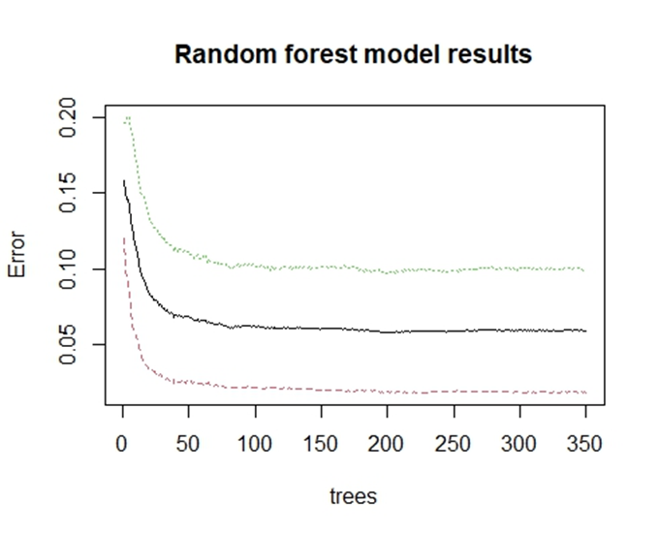
As for this model, the errors are high when the number of trees are small. The black line shows the average error across both of the other two lines as the number of trees increases. This line shows that the model was able to reduce the errors at approximately 80 trees and after that there were little improvements and the line became horizontal, indicating that there wasn’t more information for the trees to learn from.
Note: I manually selected 350 trees in order to reduce computational time. Initially, I built the plot using 500 trees. The results showed that the lines become perfectly horizontal around 175 trees so I reduced the trees because there isn’t more information to learn from after that.
The model has a low out of bag error rate of 5.88% on the training set, suggesting that the model is good. However, to have better results, I tuned the model by identifying the ideal number of variables to try at each split which was 6 variables. The tuned model produced impressive results where the number of misclassified classes dropped significantly, indicating that this model is a good fit for the data. Also, the accuracy rose from 78.5% (SVM poly model) to approximately 94%. As for the recall and f1 score, those rose from 79.18% to approximately 91% and from 78.24% to 93.73%, respectively. This makes the random forest model the winning model.
Note: When tuning the model, I used step factor of 2 which will increment the value of variables to try by 2 each time. This is an appropriate value because there are 11 predictors and the step factor of 2 will ensure that the tuning process checks an adequate number of predictors to try.
Prescriptive model results
Before translating my predictive results to the prescriptive model, I need to decide which model to use. Although Random Forest is the winning model, I decided to use logistic regression because of its interpretability as mentioned at the start of the report. I used the unscaled version of the data so I can build an interpretable optimization model. For my Decision variables, I used NumOfproducts, Balance, and IsActiveMember since they were controllable. Moreover, for my Constraints, I created a hypothetical budget of $500,000, ranged the balance from $0 to $260,000, Numofproducts from 1 to 4, restricted IsActiveMember to be binary and Numofproducts to be integers. For the objective function, I included all the variables because they were used to initially train the model. Hence, I used their median value, coefficient values, and intercept to be consistent with the initial model. The uncontrollable variables and their median values were not changed i.e were treated as constants. My goal is to minimize the objective function i.e the log odds of the variable ‘Exited’. Also, for the budget, I created a hypothetical cost for each of my decision variables per customer. I decided to spend $20 for IsActiveMember, $17.50 for NumOfProducts, and $12.50 for Balance. These costs will be multiplied with the decision variables and the solver will find the optimal budget value that does not exceed the maximum budget. According to the Solver, my optimal values were as follows:
Balance: $9998.00, IsActiveMember: 0, NumberOfproducts: 1, Budget: $124,992.5, Exited (log odds) = 0.317064183 which means the predicted probability was approximately 0.58
Sensitivity analysis
Next, based on the above results, I created a sensitivity analysis using a one-way solver table. For my analysis, I decided to vary the budget between $100,000 to $500,000 to see the range of budget for which my optimal values were still optimal. According to the solver table, when the budget varies from $100,000 to $115,000, the solver table does not reach the optimal solution. However, starting from a budget amount of $125,000 to $500,000, the optimal values obtained from the solver remain optimal. The below shows the plot to visualize the results. It shows that we do not reach the optimal values until after our budget exceeds $115,000
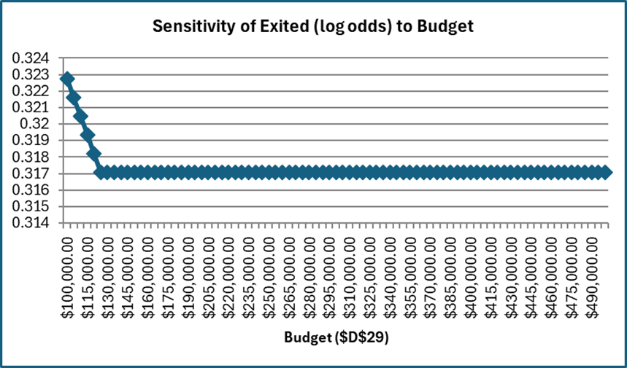

Conclusion
In conclusion, this project performed descriptive, predictive, and prescriptive analytics to help a bank reduce its customer churn. These were necessary steps in order to offer data-driven recommendations that the bank can use to improve their current customer retention strategies. Based on the above results, the following are some of the recommended marketing strategies:
- The bank needs to focus on helping the customers maintain or reach a balance of $9998.00 to prevent customers from churning, so the bank is advised to spend part of their budget to entice customers through targeted saving incentives and other promotional campaigns.
- The bank is advised to keep those inactive customers engaged to prevent them from churning. Hence, some of the budget should be used to send these customers reminders about the benefits that they are receiving from the bank so they still stay with the bank. Moreover, occasional email marketing or webinars on financial literacy tips and tricks can make these customers connected and not completely churn.
- I would recommend the bank to spend some of their budget to enhance the experience of those customers with 1 product so they do not churn. Some strategies can be excellent customer support and user friendly instructions/interface.

Appendix
1: TASK TIMES: Predicted vs. Actual
Week 5 (September 23) | Predicted | Actual
Perform exploratory data analysis and clean the data | 3 | 4
Check for missing values, influential points, and outliers | 5.5 | 4
Conduct descriptive analysis for each variable and include distribution charts | 5 | 6
Create correlation charts for the variables | 2 | 3
Complete descriptive analysis results memorandum | 4 | 3
Week 6 (September 30)
Make a list of candidate models for the data | 1 | 0.75
Explain data transformation, check for collinearity and change predictors, if necessary | 2 | 1
Train, test, tune, optimize the models and avoid overfitting | 7 | 8
Week 7 (October 7)
Compare models using metrics and create visuals | 5 | 3
Complete writing predictive results memorandum | 3 | 4
Week 8 (October 14)
Perform sensitivity analysis using those predictors that were linked to churn based on predictive analytics | 4 | 6
Offer customer retention strategies based on sensitivity analysis results | 3 | 2
Week 9 (October 21)
Create visuals to show results of sensitivity analysis | 2 | 0.5
Week 10 (October 28)
Write the prescriptive analysis results | 4 | 3
Week 11 (November 4)
Prepare executive summary draft and finalize it | 5 | 2
Week 12 (November 11)
Discuss subject matter, problem statement, and analysis method | 2 | 1
Discuss findings, conclusions, and limitations - 2hr | 2 | 1
Week 13 (November 18)
Prepare powerpoint slides | 4 | -
Record presentation | 1 | -
Review presentation and make adjustments | 2 | -
Week 14 ( November 25)
Review peers’ presentation | 3 | -
Make changes to my project according to peer feedbacks | 2 | -
Week 15 ( December 2)
Finalize my project using peer feedback and submit the revised report | 2 | -

Reference
Mihup. (2024, February 15). Bank customer churn prediction. https://mihup.ai/maximizing-retention-bank-customer-churn-prediction/
Singh, P. P., Anik, F. I., Senapati, R., Sinha, A., Sakib, N., & Hossain, E. (2024). Investigating customer churn in banking: A machine learning approach and visualization app for data science and Management. Data Science and Management, 7(1), 7–16. https://doi.org/10.1016/j.dsm.2023.09.002
S. F. Slater, and J. C. Narver. “Intelligence Generation and Superior Customer Value.” Journal of the Academy of Marketing Science, vol. 28, no. 1, 2000, pp. 120–27.

